COMPUTER ARCHITECTURE
CSA1204-SLOT C

- EXPERIMENT 1 - ADDITION OF TWO NUMBERS
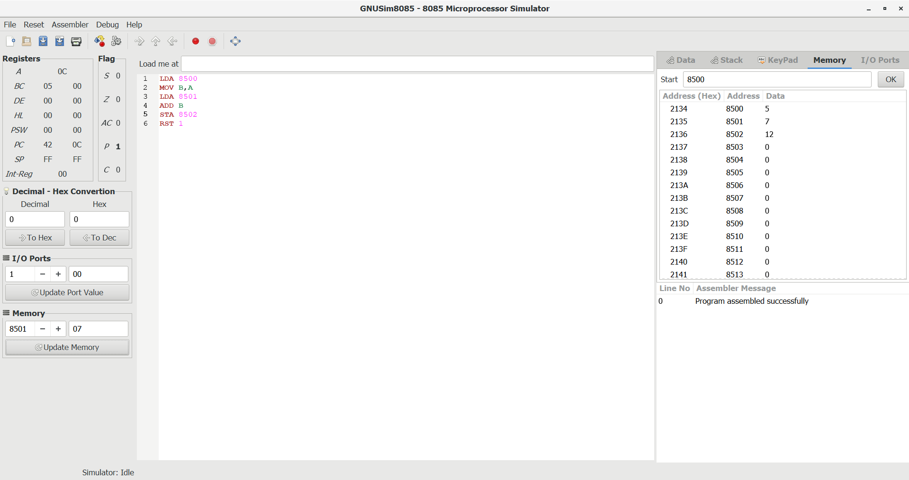

EXPERIMENT 2 – SUBRACTION OF TWO NUMBERS
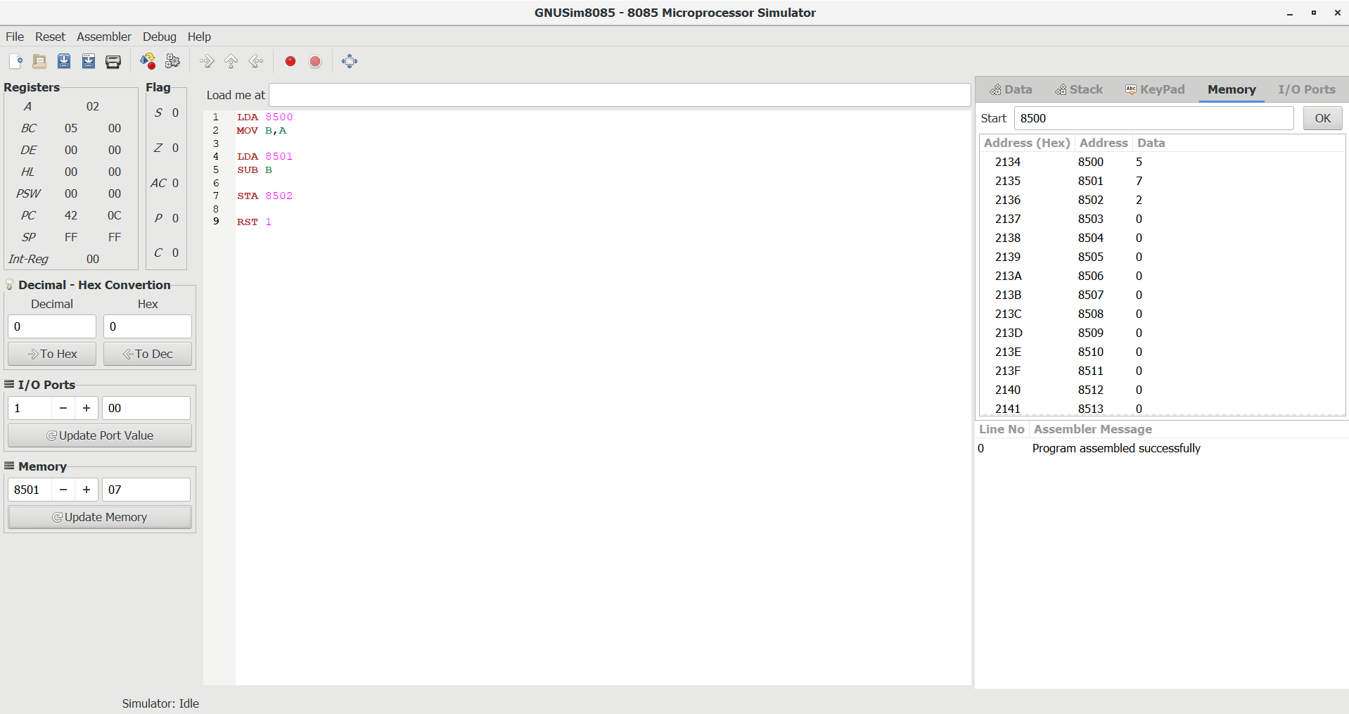
EXPERIMENT 3 – ADDITION WITH CARRY
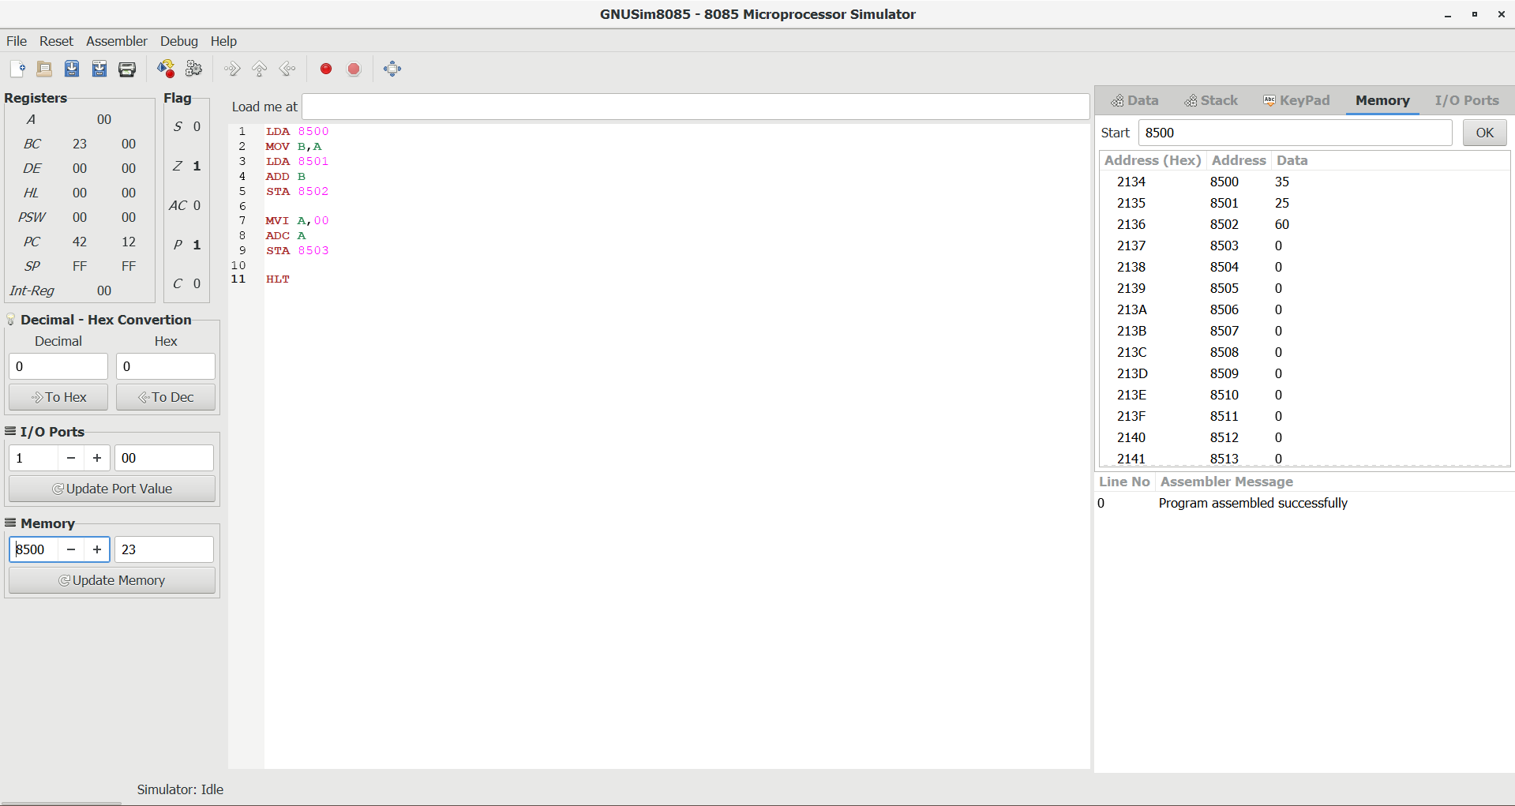
EXPERIMENT 4 – SUBRACTION OF TWO NUMBERS WITH BORROW
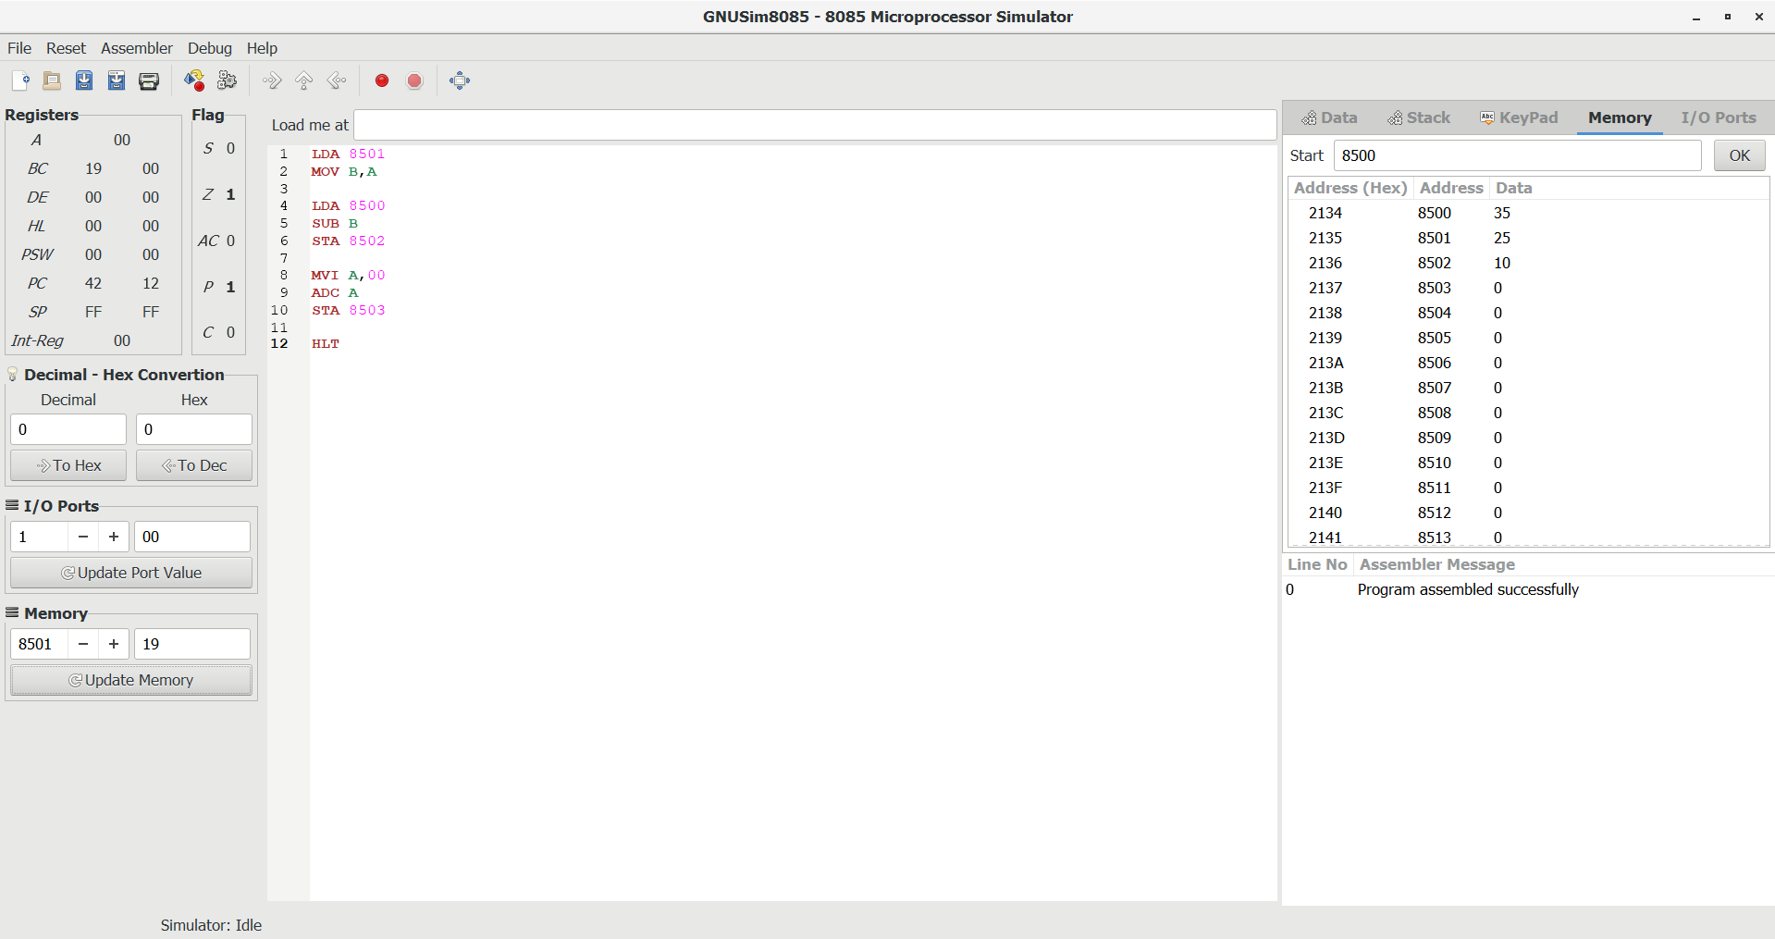
EXPERIMENT 5 – MULTIPLICATION OF TWO NUMBERS
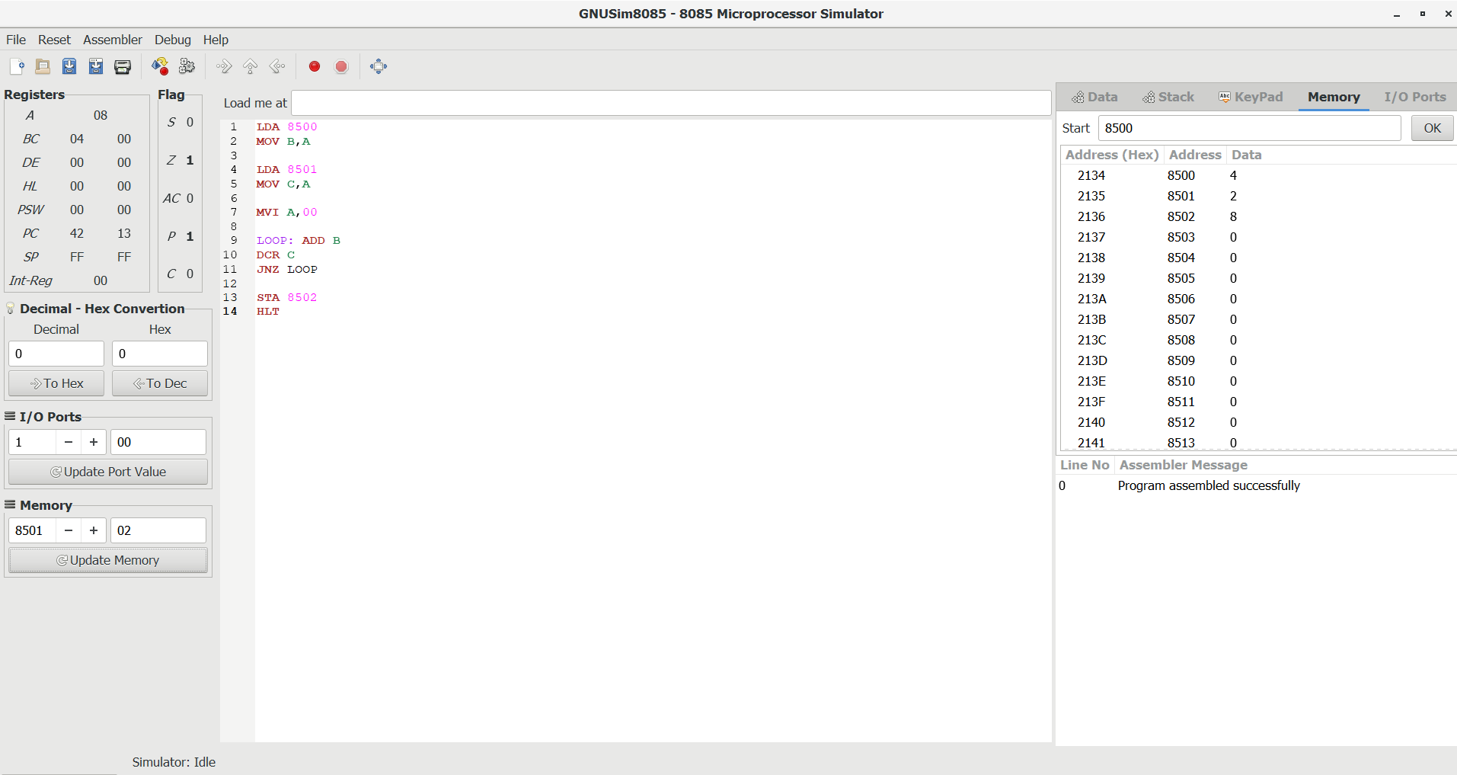
EXPERIMENT 6- DIVISION OF TWO NUMBERS
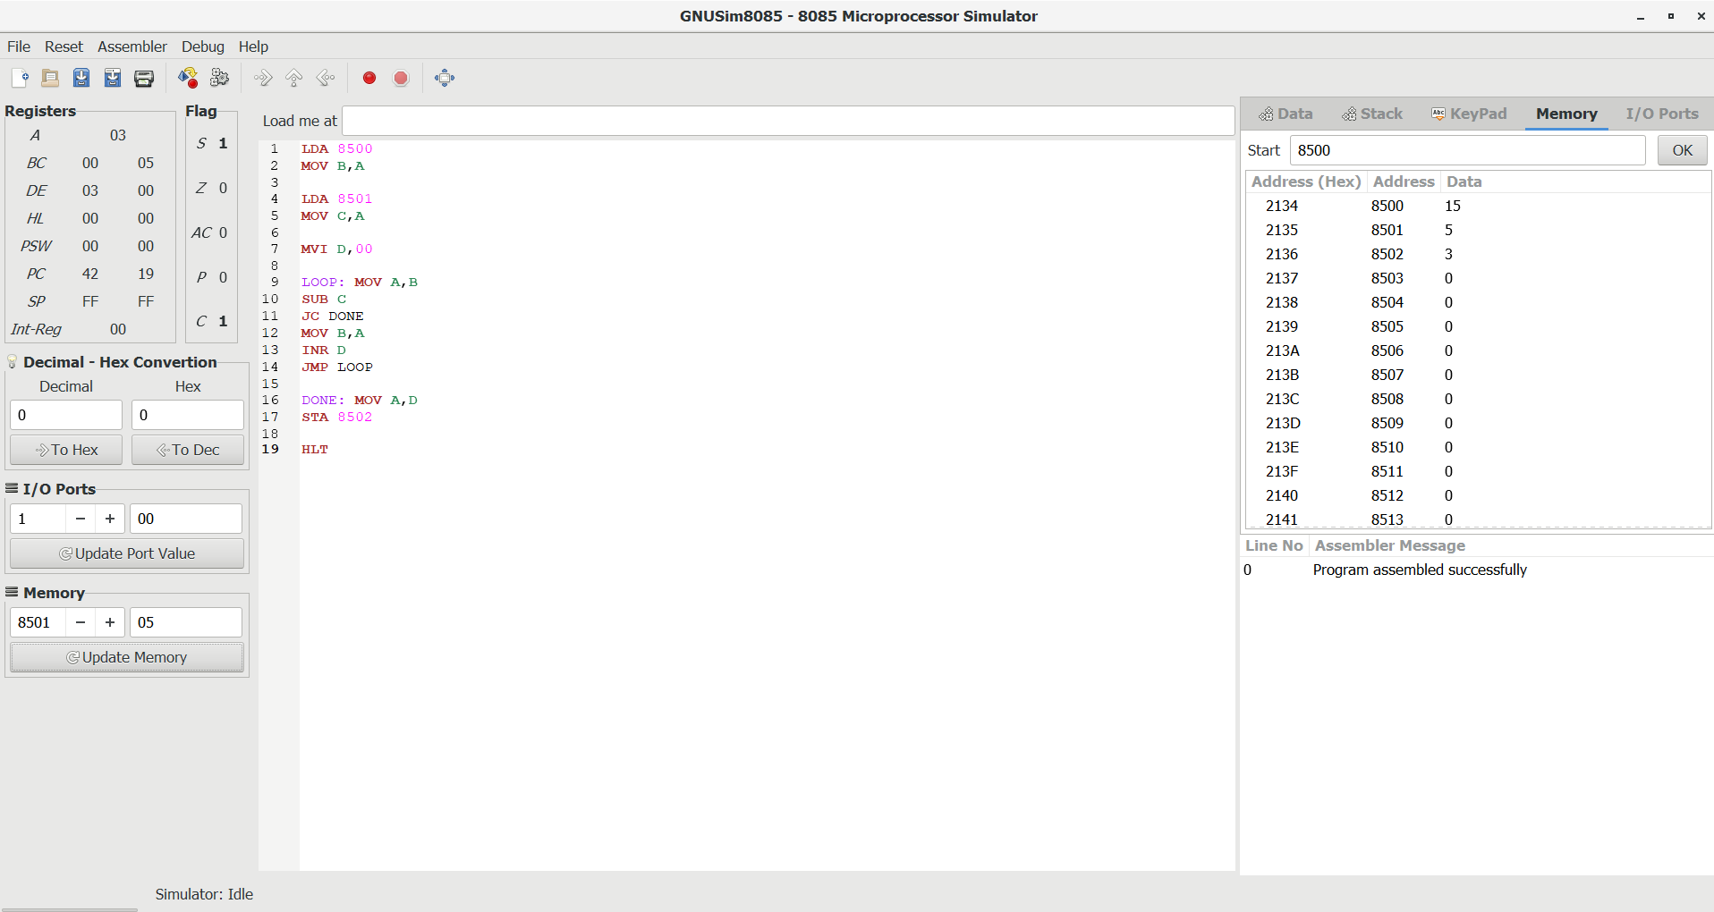
EXPERIMENT 7- Write an assembly language program for multiplication of two 16-bit data using 8085 processor
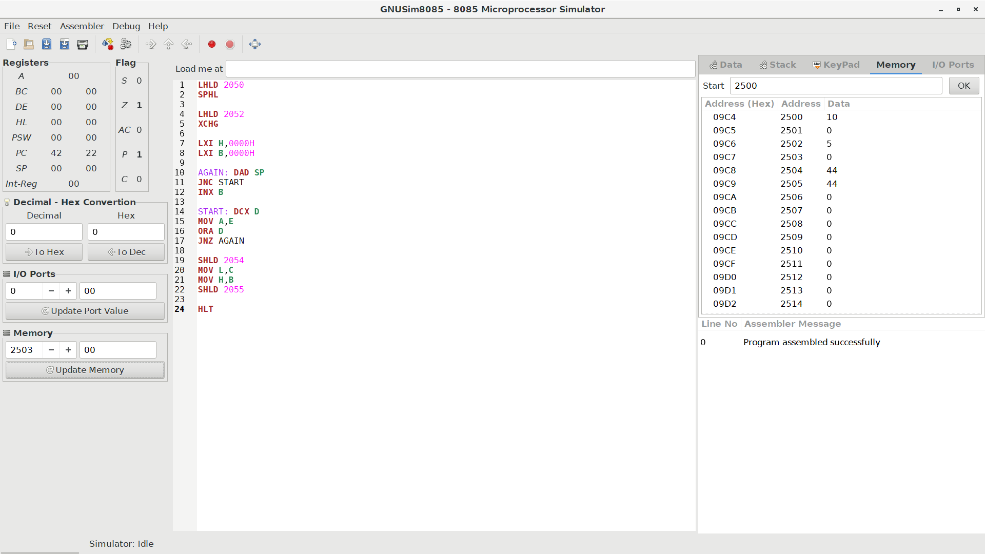
EXPERIMENT 8- Write an assembly language program for division of two 16-bit data using 8085 process
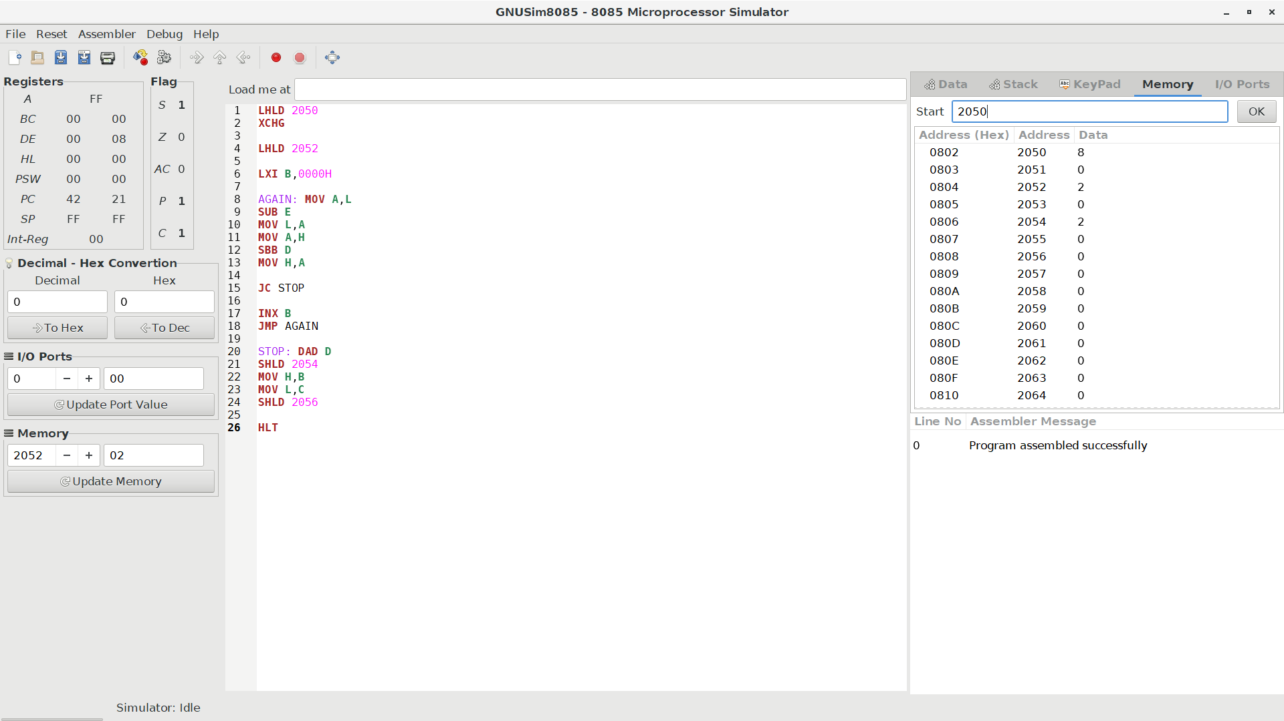
EXPERIMENT 9- Write an assembly language program for adding two 16-bit data using 8086 processor.
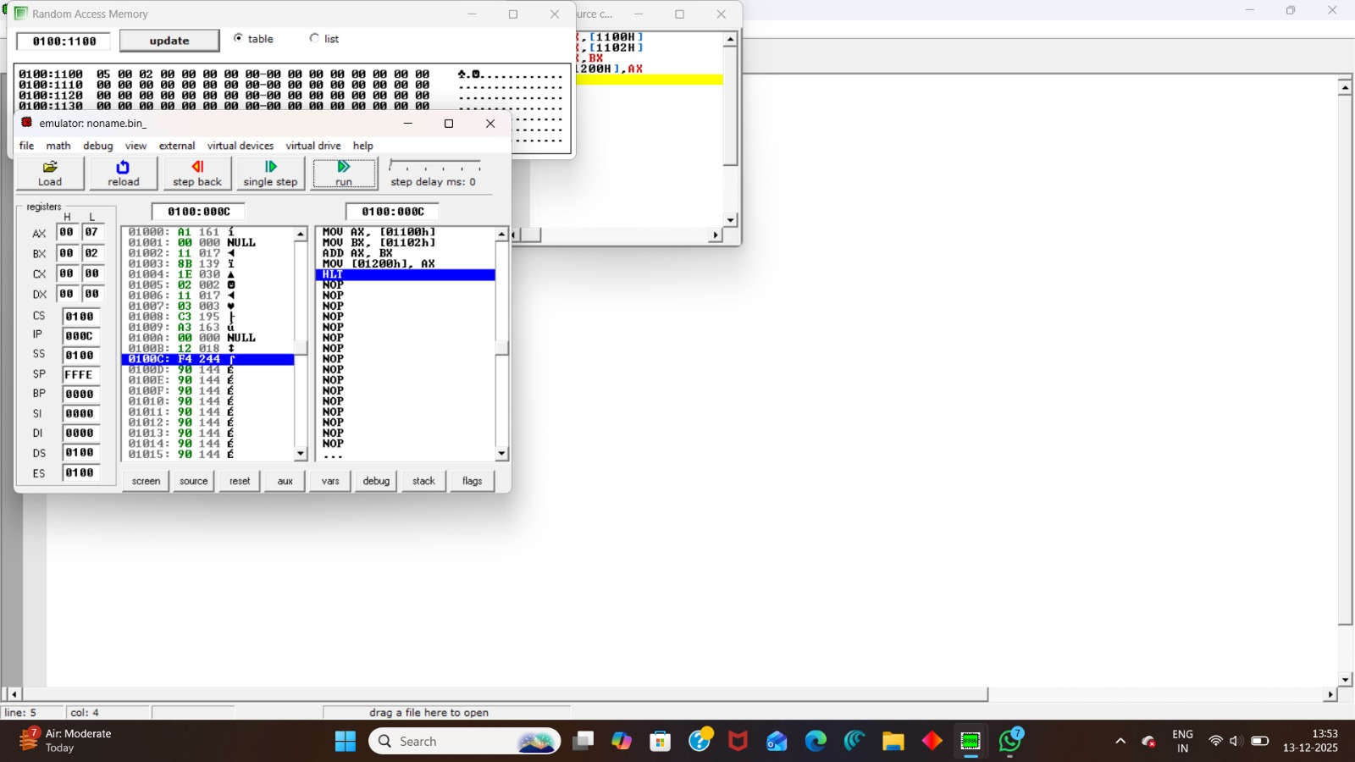
EXPERIMENT 10- Write an assembly language program for subtracting two 16-bit data using 8086 processor.
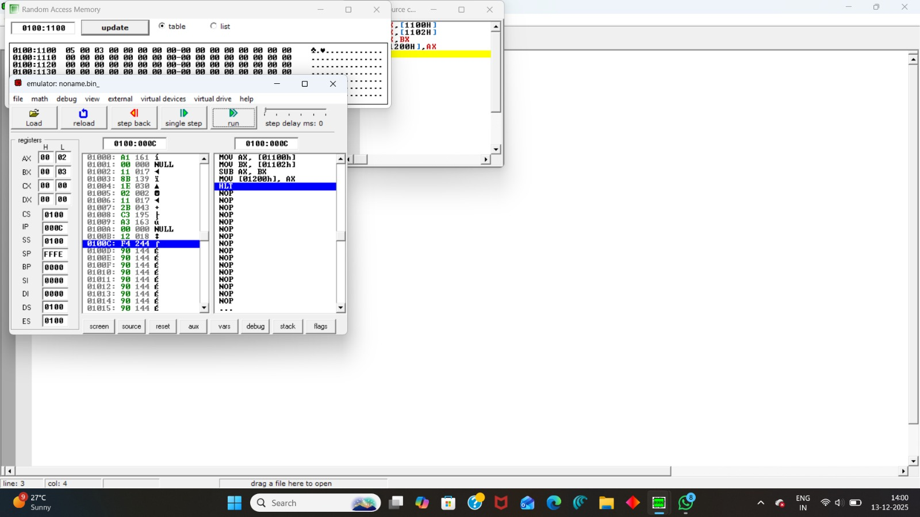
EXPERIMENT 11- Write an assembly language program for multiplying two 16-bit data using 8086 processor.
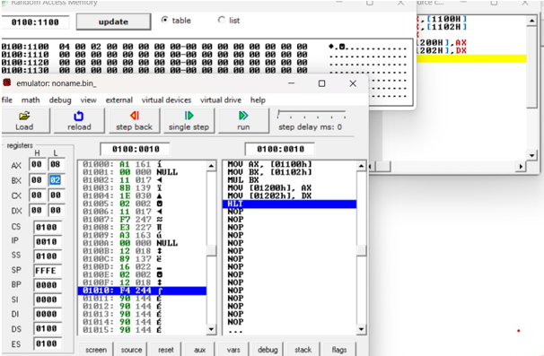
EXPERIMENT 12- Write an assembly language program for dividing two 16-bit data using 8086 processor.
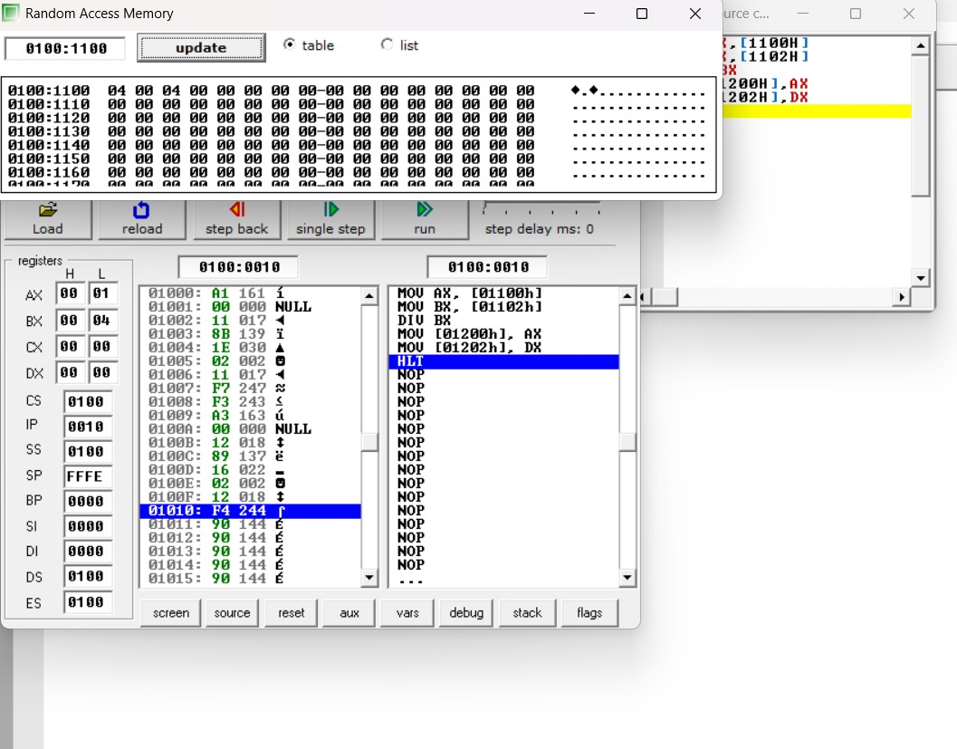
EXPERIMENT 13-Write an assembly language program to find the Greatest of 2 numbers.
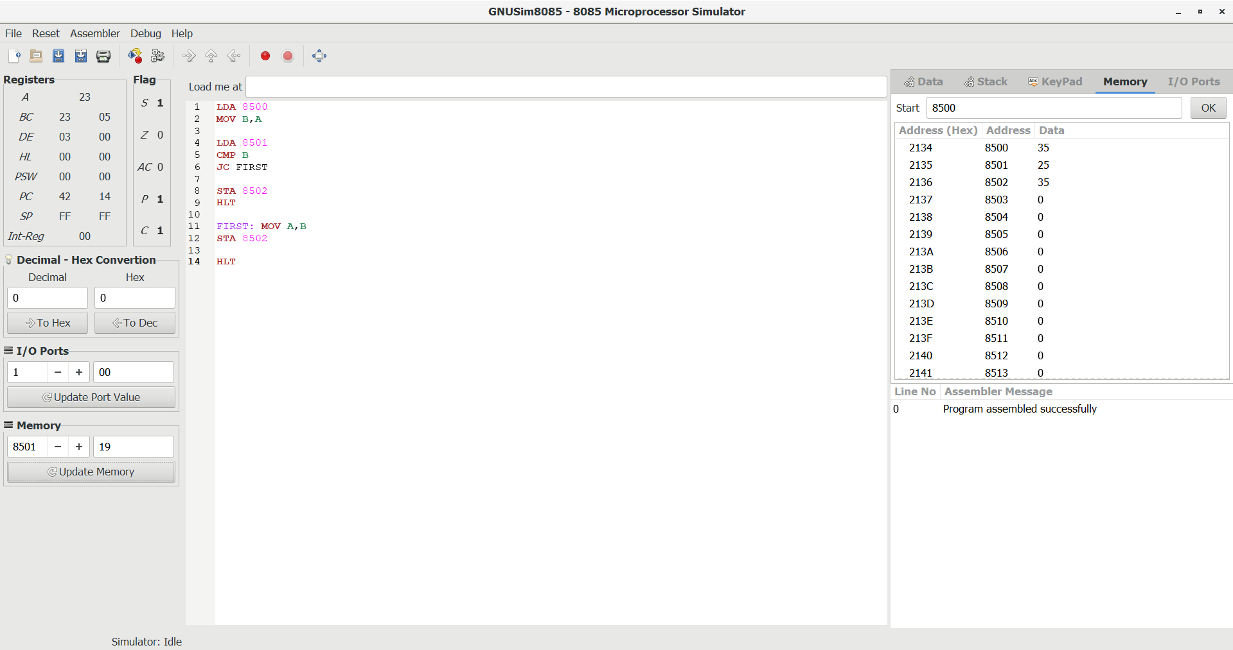
EXPERIMENT 14 – Write an assembly language program to find the Smallest of 2 numbers.
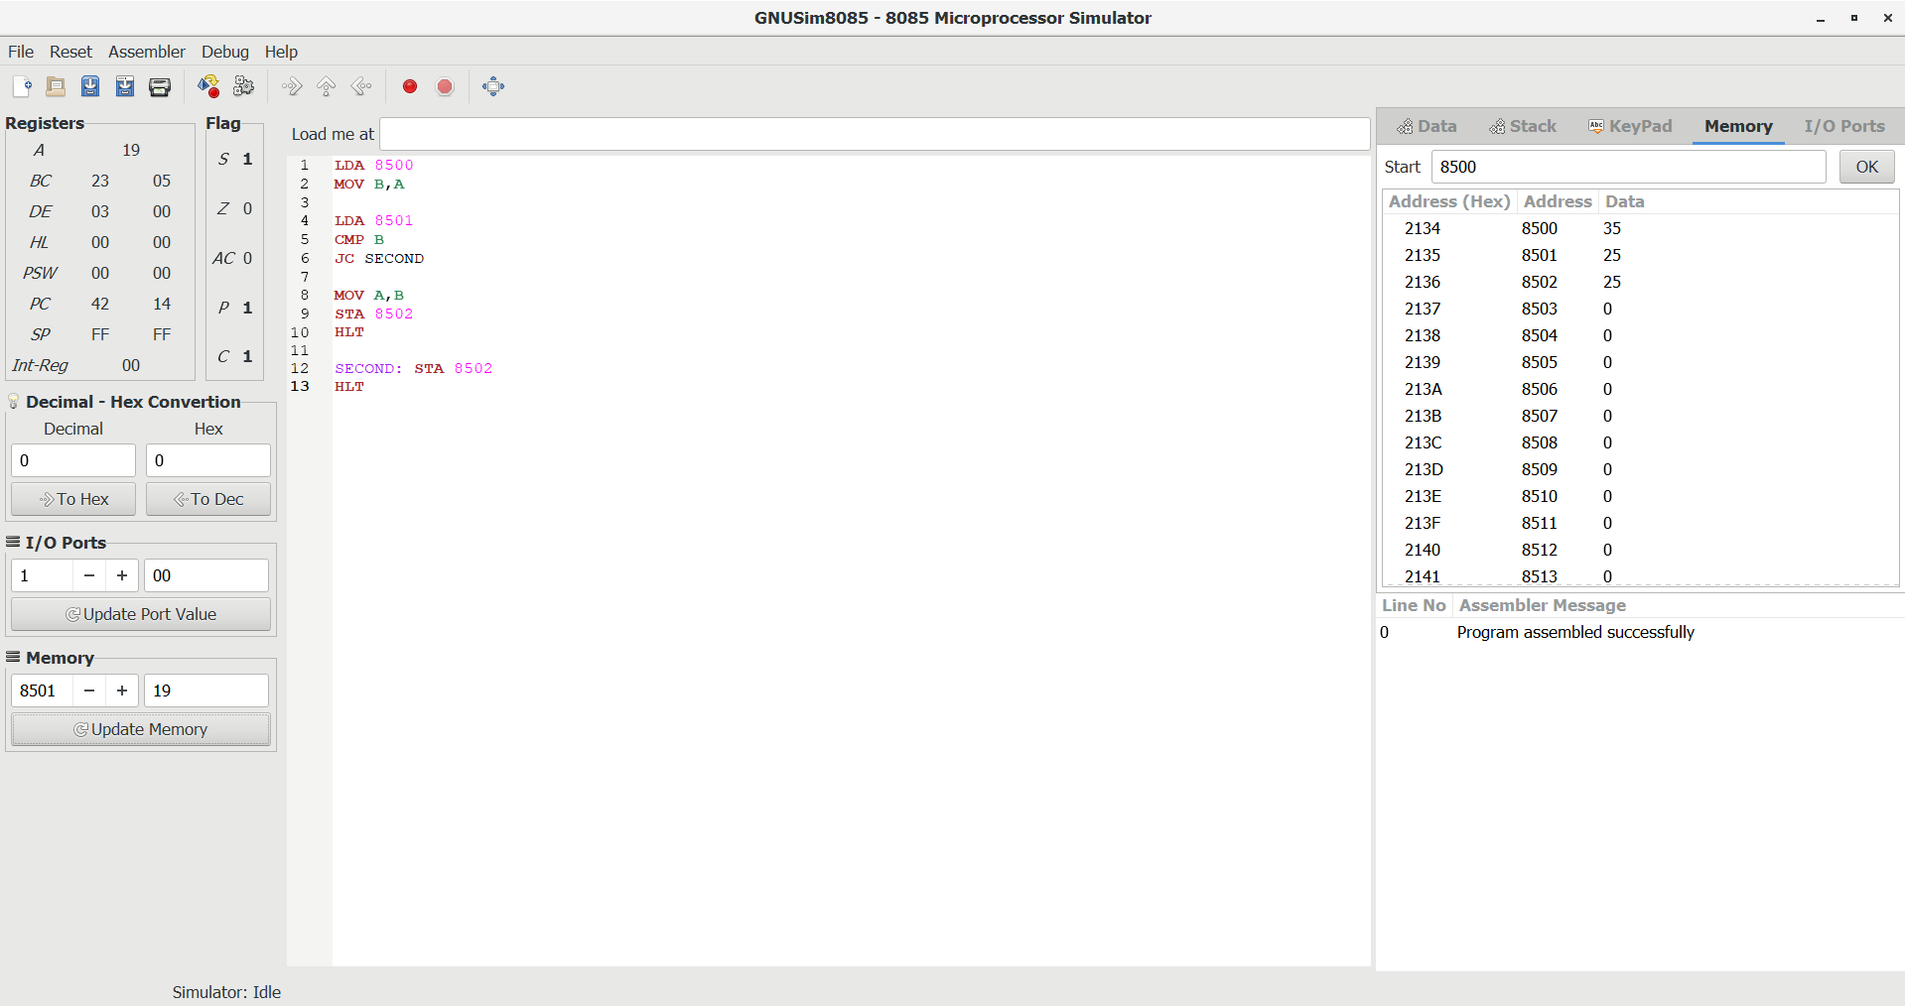
EXPERIMENT 15 – Write an assembly language program to swap two 8-bit data using 8085 processor.
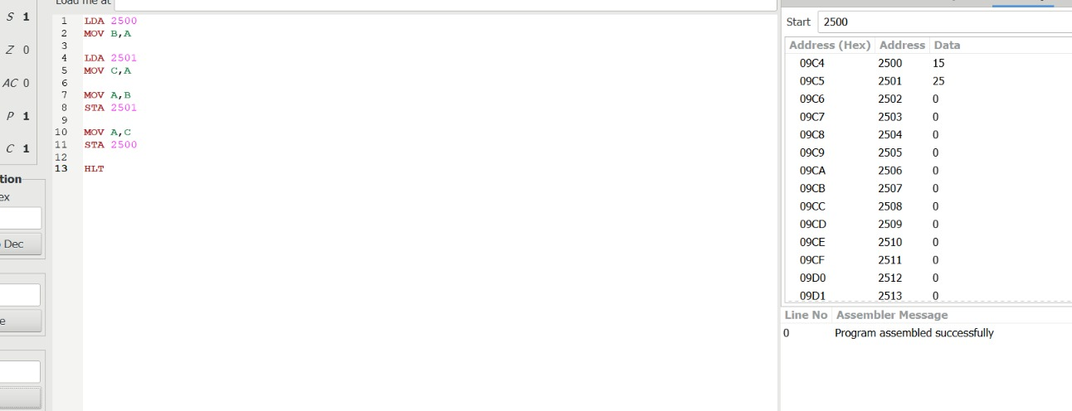
EXPERIMENT 16 – Write an assembly language program to find 1’s complement of 8-bit number.
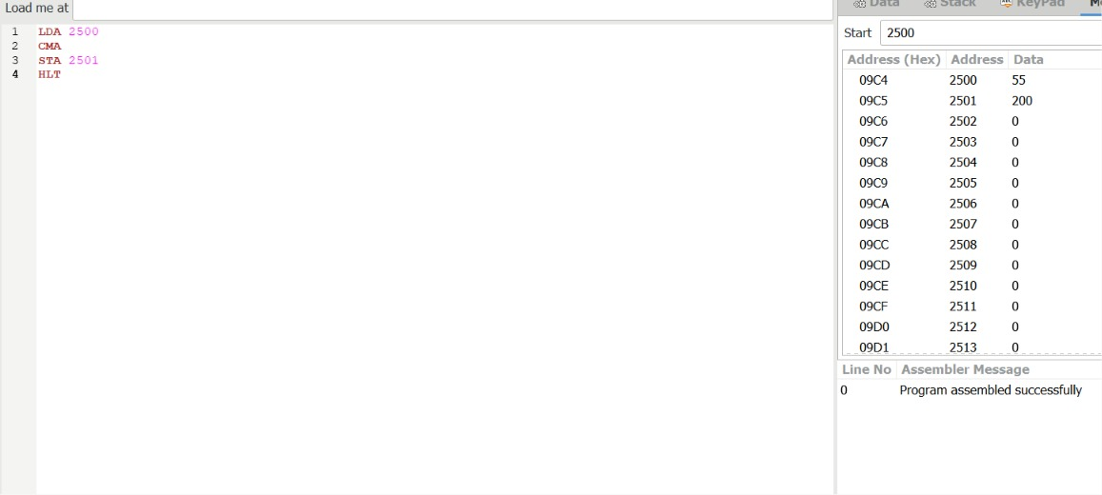
EXPERIMENT 17 – Write an assembly language program to find 2’s complement of 8-bit number.
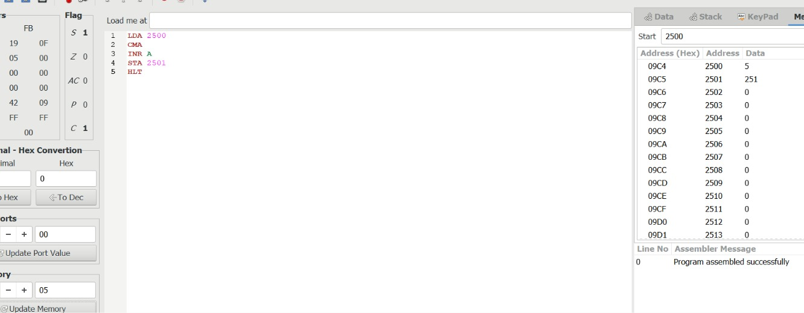
EXPERIMENT -18 Write an assembly language program to find the given 8-bit number is Odd or Even using 8085 processor.
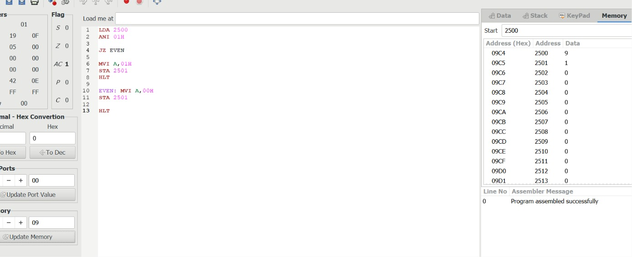
EXPERIMENT –19. Write an assembly language program to find the given 8-bit number is Positive or Negative using 8085 processor.
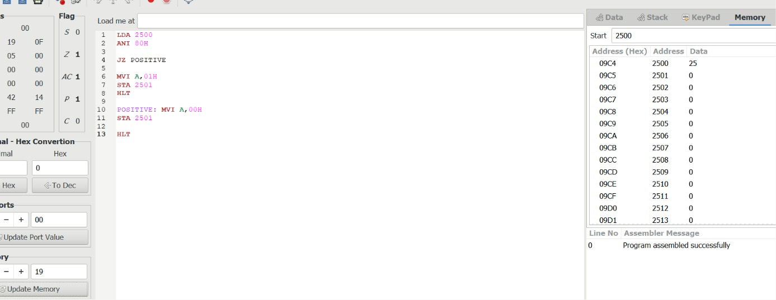
EXPERIMENT – 20 Write an assembly language program to arrange numbers in Ascending order
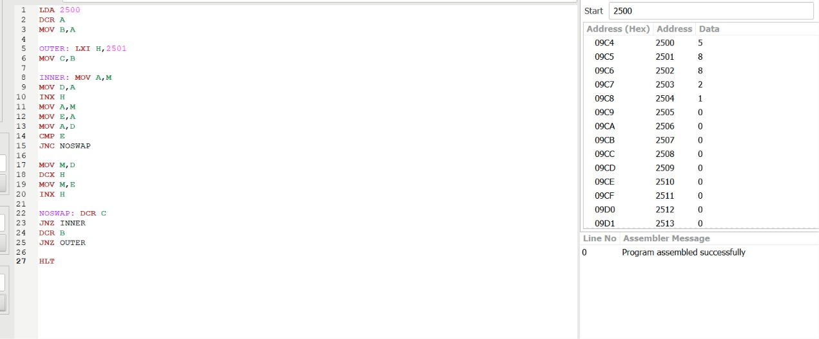
EXPERIMENT 21 - Write an assembly language program to arrange numbers in Descending order.
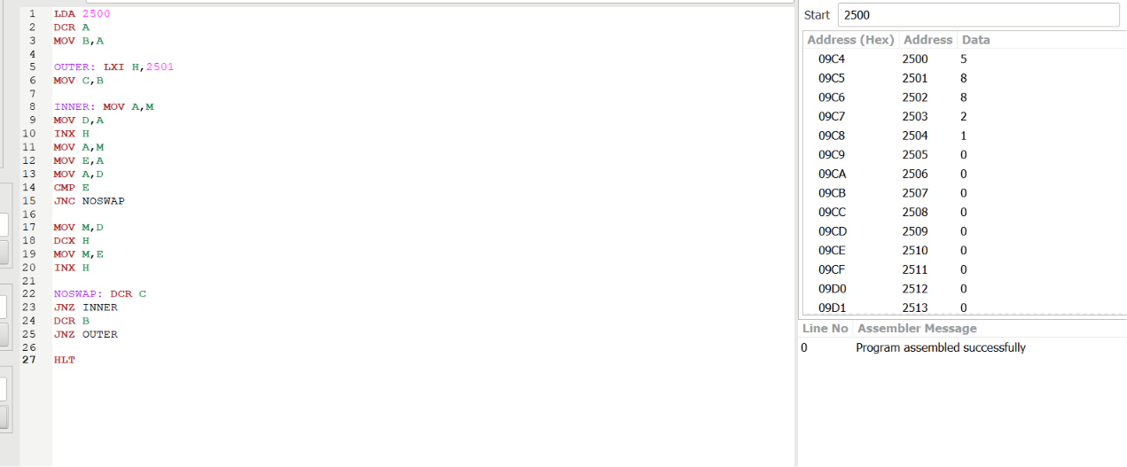
EXPERIMENT 22– Write an assembly language program to find the largest number in an array
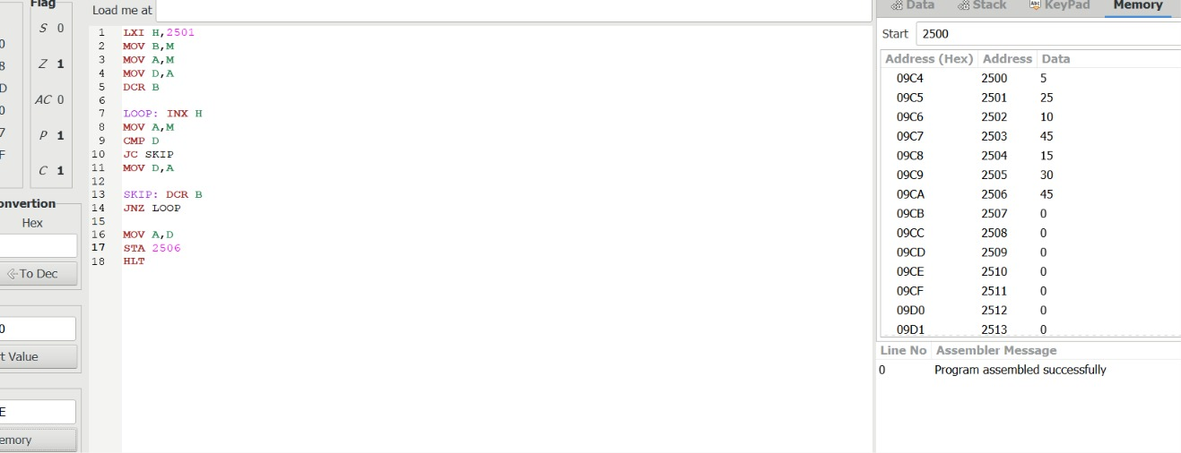
EXPERIMENT 23 – Write an assembly language program to find the Minimum number in an array.
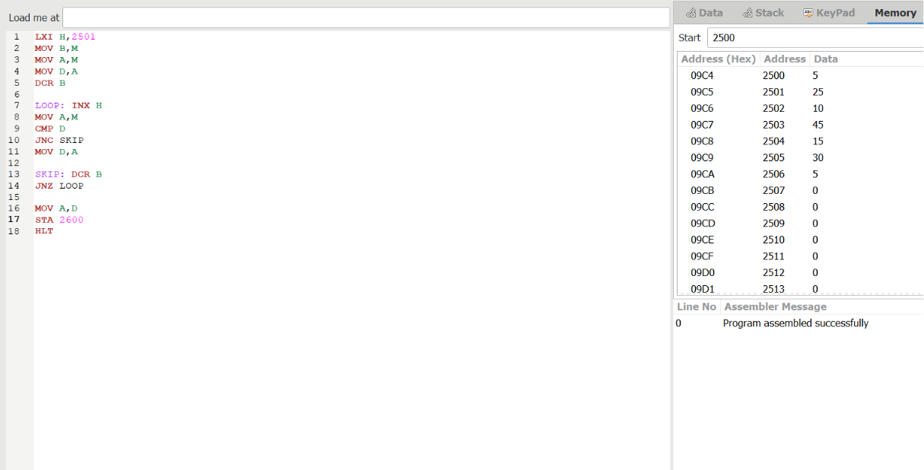
EXPERIMENT 24 Write an assembly language program to find the LCM of 2 numbers.
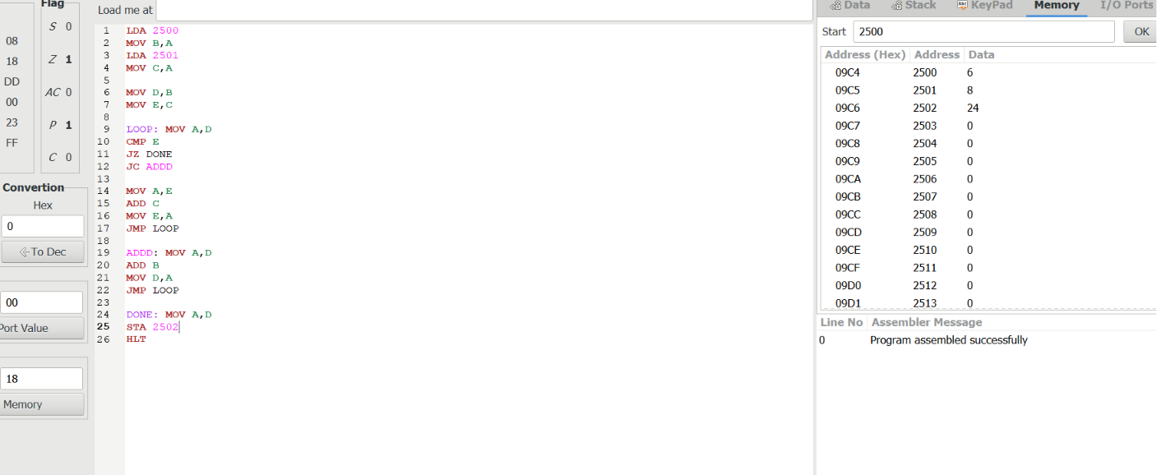
EXPERIMENT 25 – Write an assembly language program to find the GCD of 2 numbers.
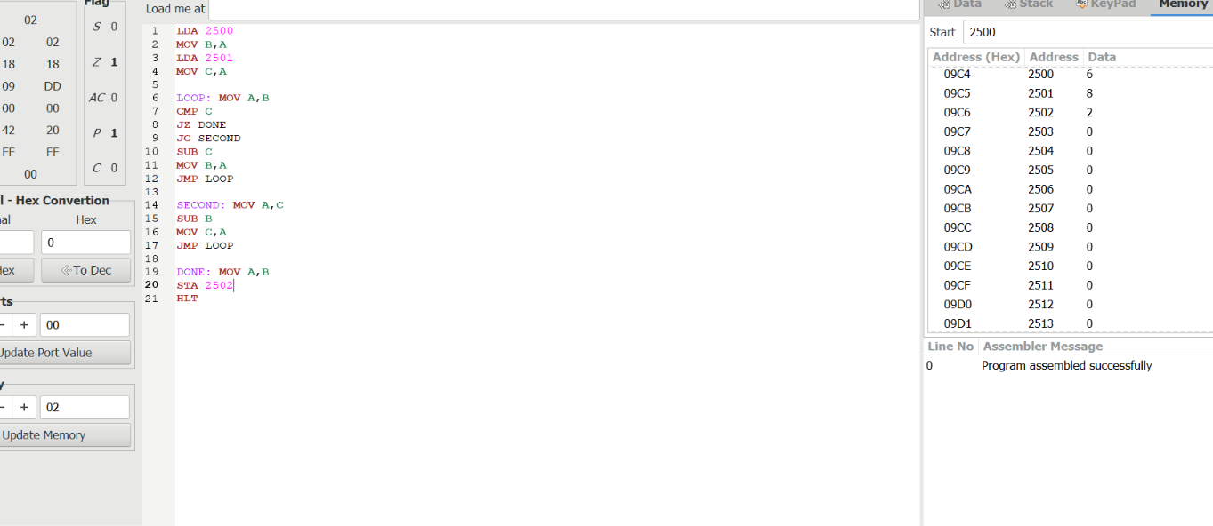
EXPERIMENT 26 – Write an assembly language program to find factorial of n in the given number.
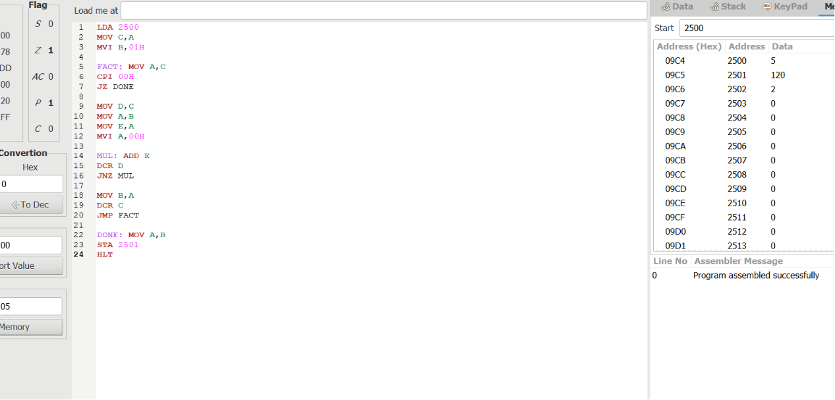
EXPERIMENT 27 – Write a program to convert Decimal number to Hexadecimal number
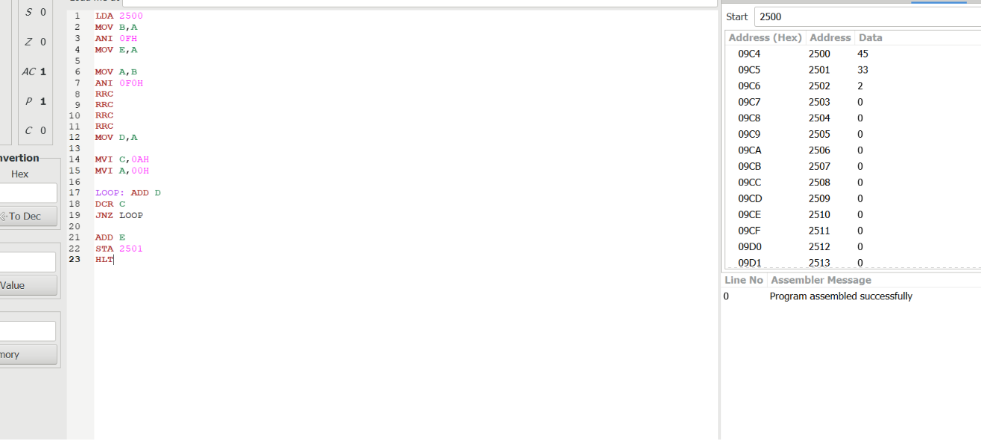
EXPERIMENT 28 – Design a circuit for the below mentioned diagram and implement the same using Logisim simulator
HALF ADDER
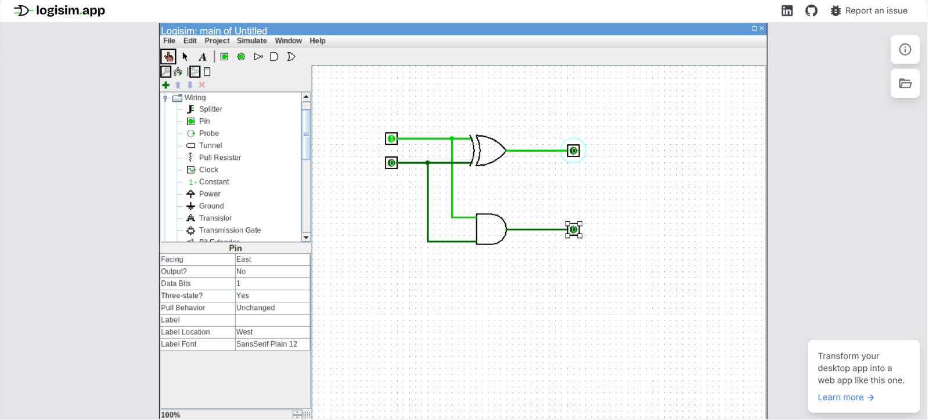
EXPERIMENT 29 – Design a circuit for the below mentioned diagram and implement it using Logisim simulator.
FULL ADDER
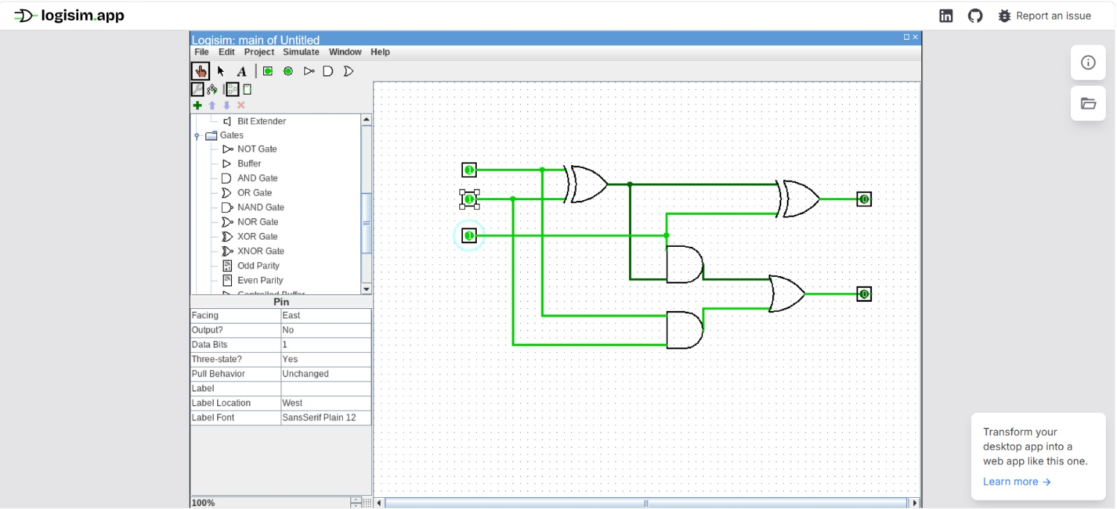
EXPERIMENT 30– HALF SUBTRACTOR
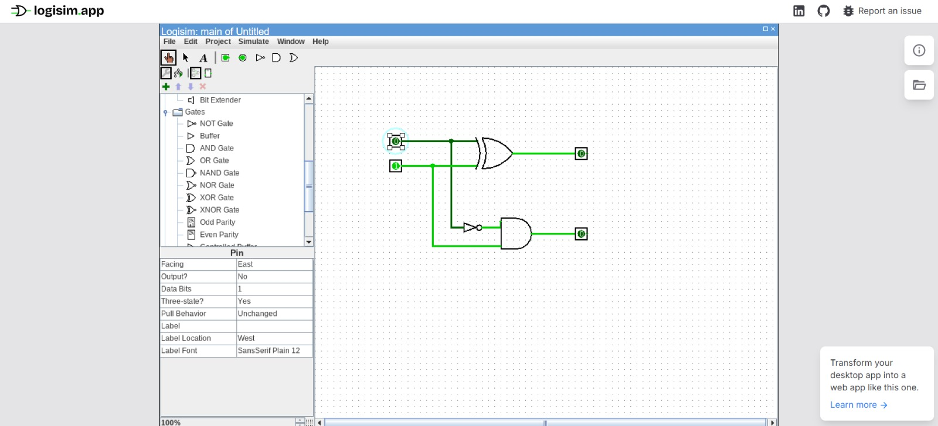
EXPERIMENT 31 – FULL SUBTRACTOR
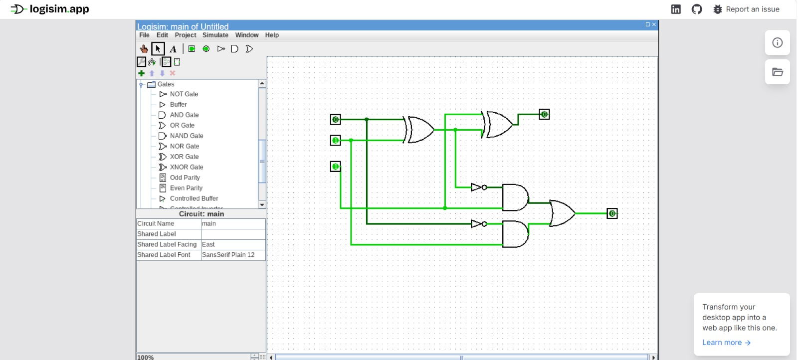
EXPERIMENT 32 -
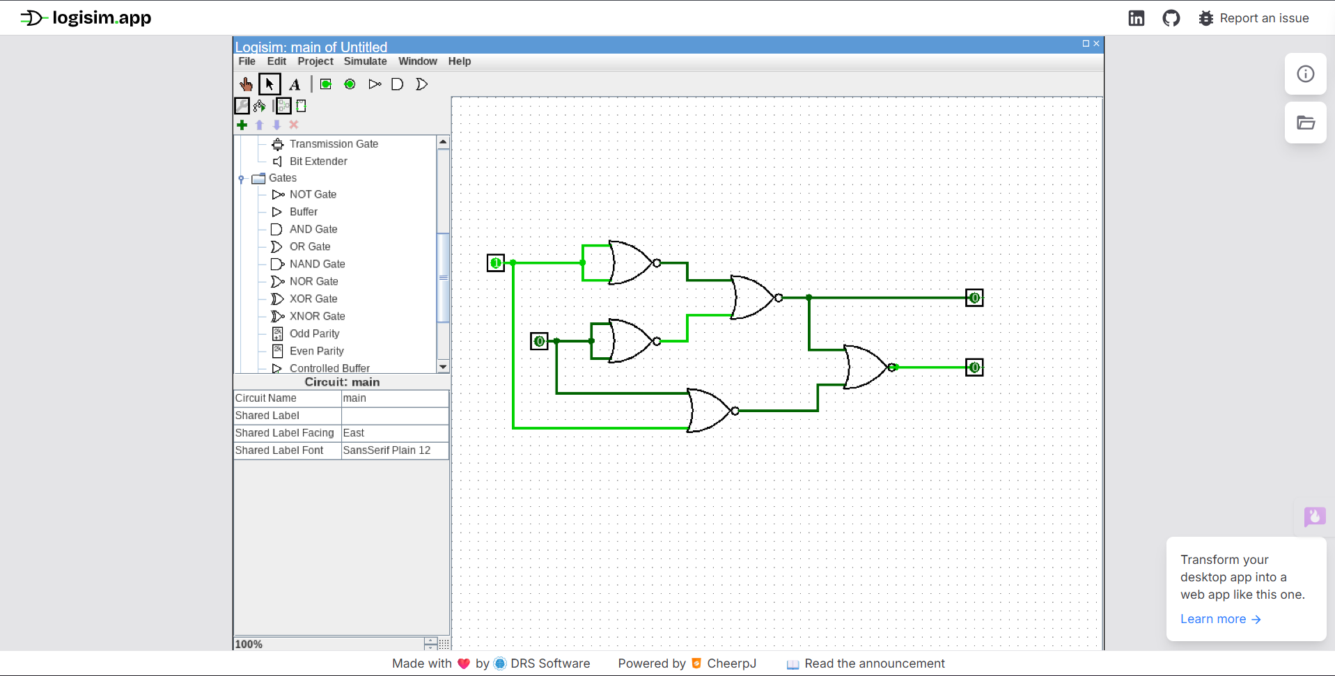
EXPERIMENT 33 –
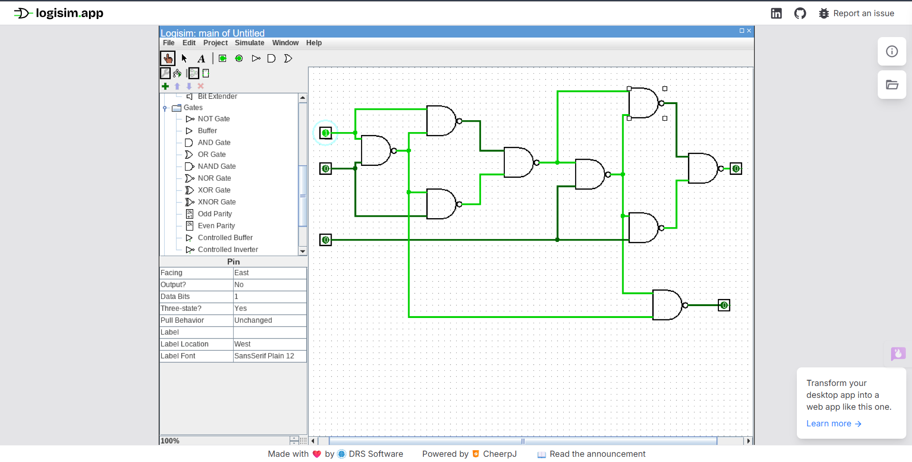
EXPERIMENT 34 – 16 BIT ADD
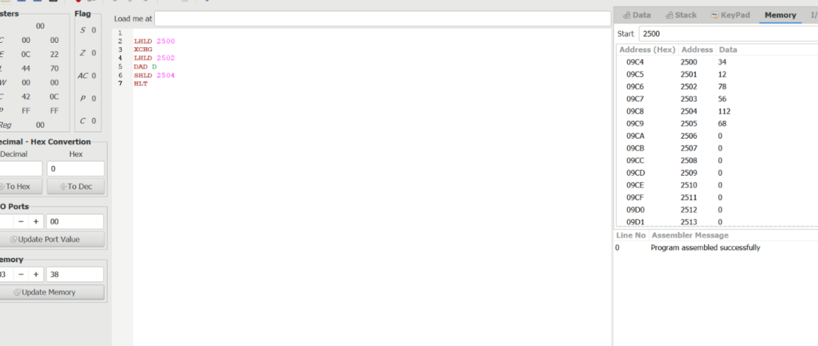
EXPERIMENT 35 - 16 BIT SUB
